|  |  |
| --- | --- |
| Nikon D850 (Body Only)  Máy ảnh Nikon D850 (Body Only) | Chính Hãng  Nikon D850.2 Nikon D850.1 Nikon D850.3 Nikon D850.4 | **Featured information:**Sensor: Full-frame resolution: 45.7MPISO range: 64 - 25600 (expandable 32 - 102400)Wireless connection: WiFi, bluetooth LCD touch screen 3.2  **Price : $2900**  **Specifications:**  Sensor Type  CMOS  Image Format  JPEG, Raw, TIFF  Anti-Vibration  No  Lens Mount  Nikon F  Sensor Format  Full-Frame (1x Crop Factor)  Resolution  46.89 Megapixels  Size photo  8256 x 5504  Image Proportions  1:1, 3:2, 4:5 |

**Overview:**

After 3 years since the launch of the D810, Nikon introduced the next generation to consumers around the world, the Nikon D850, at the end of August 2017. Nikon's D850 is expected to be the company's first FullFrame camera with the ability to optimize high image resolution, processing speed and performance. This is also the first FullFrame camera in the world capable of recording 8K resolution Timelapse videos.

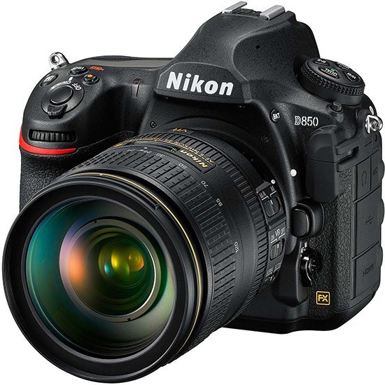

Nikon's flagship DSLR camera is equipped with a 45.7MP BSI CMOS FullFrame Sensor and the company's latest EXPEED 5 Image Processor. This is the first time Nikon has equipped a super high resolution for its FullFrame camera. The high resolution of the camera requires a fast image processor and ensures the performance of the camera. That's why the company brought the EXPEED 5 processor into the mix to deliver high image quality with vivid colors and contrast. The D850's sensor also has the Optical Lowpass Filter removed to provide more detailed images.

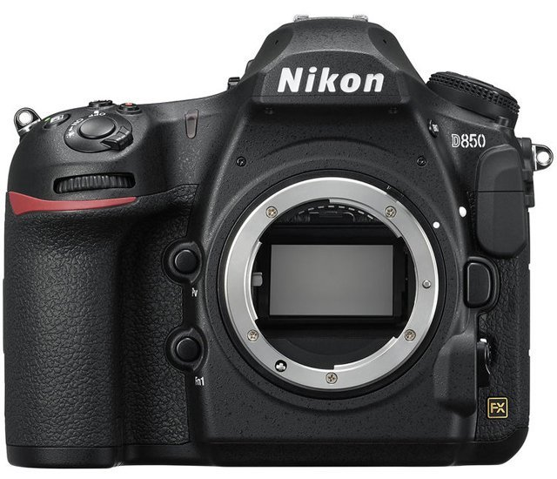

Nikon equips the D850 with a 153-point phase-detection focus system, including 99 Crosstype points to enhance object movement detection and 15 points to support f/8 aperture. The new focus system helps the D850 focus quickly and accurately even in low light conditions or fast-moving objects and supports continuous focusing during video recording. The camera can focus in light conditions as low as −4EV and even with subjects with very low contrast.

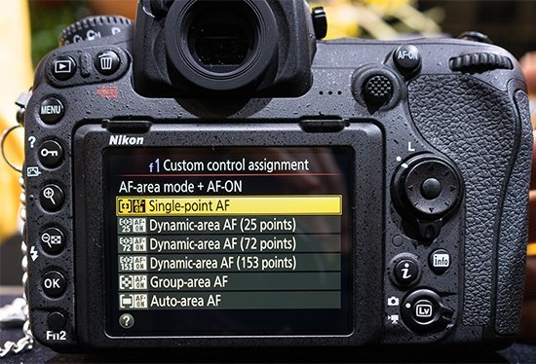

Equipped with powerful hardware, the Nikon D850 is capable of recording 4K UHD video at 30 fps/s or Full HD at 120 fps/s. In addition, the device also has the ability to record 8K videos in Timelapse format, simulating time and fast-moving scenes with extremely high clarity and smoothness. The camera supports a stereo microphone or an optional external mic added via the 3.5mm stereo jack for better quality control and live monitoring of audio during recording.